Practice problems

Question 1
• Download dataset → GitHub test_db
• Create database:
mysql -u root -p -e "CREATE DATABASE employees;"
• Switch to CMD & import:
mysql -u root -p employees < employees.sql
• Verify tables:
mysql -u root -p -e "SHOW TABLES IN employees;"
• Install Python dependencies:
pip install pymysql
• Write generator-based Python script
• Run the script:
python stream_generator_example.py
• Successfully processed large dataset with low memory usage

Output:--

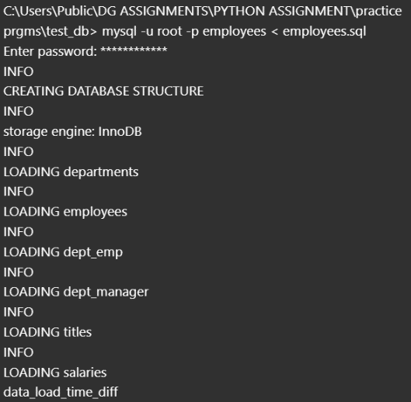

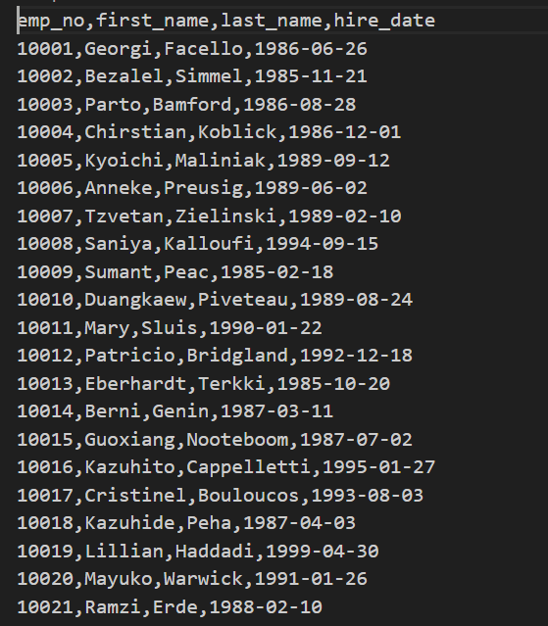

Question 2

Implement Person, Male, Female classes (with abstract class)

What I implemented
I wrote the class definitions using Python’s ABC module:
from abc import ABC, abstractmethod

class Person(ABC):
@abstractmethod
def get_gender(self):
pass

class Male(Person):
def get_gender(self):
return "Male"

class Female(Person):
def get_gender(self):
return "Female"

How I validated
- Instantiated Male() → returned "Male".
- Instantiated Female() → returned "Female".
- Tried Person() → throws TypeError (correct behavior).
Output:

Question 3

Remove duplicates from list while preserving order

What the question asked
Given list:
[12,24,35,24,88,120,155,88,120,155]
You must:
- Remove duplicates
- Preserve order
- Use set() to track seen elements

What I implemented
data = [12, 24, 35, 24, 88, 120, 155, 88, 120, 155]

seen = set()
result = []

for item in data:
if item not in seen:
seen.add(item)
result.append(item)

print(result)

Output
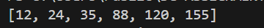

Question 4

Generate list of squares from 1 to 20 using map() + lambda

What the question asked
Use:
- map()
- lambda
- Range 1 to 20 (inclusive)

What I implemented
squares = list(map(lambda x: x * x, range(1, 21)))
print(squares)

Output

Validation
- All values correct
- Lambda applied via map correctly

Question 5

anti_html.py — Remove HTML Tags From URL Content

What the question asked
Create a script:
- Takes URL as command-line argument
- Downloads the HTML
- Removes all HTML tags
- Prints clean text

What I implemented
#!/usr/bin/env python3

import sys
import urllib.request
import re

def strip_html_tags(html):
html = re.sub(r"(?is)<(script|style).*?>.*?</\1>", "", html)
html = re.sub(r"<[^>]+>", "", html)
html = re.sub(r"\s+", " ", html)
return html.strip()

def main():
if len(sys.argv) != 2:
print("Usage: python anti_html.py <URL>")
sys.exit(1)

url = sys.argv[1]

try:
response = urllib.request.urlopen(url)
html = response.read().decode("utf-8", errors="ignore")
except Exception as e:
print("Error fetching URL:", e)
sys.exit(1)

clean_text = strip_html_tags(html)
print(clean_text)

if __name__ == "__main__":
main()

How I validated
- Provided a URL and observed stripped HTML content
- Verified script removes tags and returns readable text
- Verified command-line usage:

Output:

python Q5.py https://fast.com/

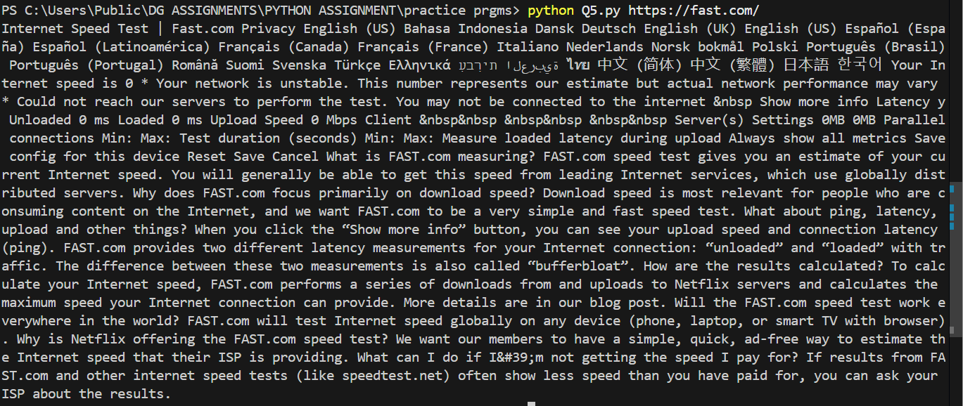

Assignment –Unit Testing

1 — Cloned repo
If you hadn’t forked first, you can still fork later. I cloned locally first:
git clone https://github.com/<original-owner>/python-unittest-exercise.git
cd python-unittest-exercise
Note: if you cloned upstream (not your fork), you must push to your fork later (I describe this in the Git section).

2 — Create a Python 3.11 virtual environment and activate it
I installed Python 3.11 and created a venv named .venv311 (so it’s explicit):
# Create venv (replace path with your python 3.11 if necessary)
py -3.11 -m venv .venv311

# Activate venv
.\.venv311\Scripts\Activate.ps1

# verify
python --version # must show Python 3.11.x
Reason: botocore imports cgi (deprecated/removed in Python 3.14). Using Python 3.11 avoids compatibility errors.

3 — Install project dependencies
From project root with venv active:
pip install -U pip
pip install -r requirements.txt
# if requirements.txt missing anything: pip install pytest moto boto3 pytest-cov

4 — Run tests first to see baseline
pytest -q
This showed errors initially (Python 3.14 issues earlier; after switching to 3.11 tests collected but two DynamoDB tests failed due to float vs Decimal). These test failures acted as my spec.

5 — Implement code changes

A. tdd_example.py — implement methods (TDDExample)
I implemented the four class methods so they match tests:
class TDDExample():
def __init__(self):
pass

def reverse_string(self, input_str: str) -> str:
return input_str[::-1]

def find_longest_word(self, sentence: str) -> str:
words = sentence.split()
return max(words, key=len) if words else ""

def reverse_list(self, input_list: list) -> list:
return input_list[::-1]

def count_digits(self, input_list: list, number_to_be_counted: int) -> int:
return input_list.count(number_to_be_counted)

B. tests/test_general_example.py — write unit tests, mock DB call
I implemented pytest test file to cover GeneralExample.flatten_dictionary and GeneralExample.fetch_emp_details. Key points:
- Used unittest.mock.patch (or monkeypatch) to mock GeneralExample.load_employee_rec_from_database so tests run fast (no time.sleep(10)).
- Tests included normal cases, duplicates, empty input and multiple fetch scenarios.
Example test outline (already added to repo):
def test_flatten_dictionary_basic(): ...
def test_flatten_dictionary_with_duplicates_and_unsorted(): ...
def test_flatten_dictionary_empty(): ...
def test_fetch_emp_details_with_mocked_db_record(): ...
def test_fetch_emp_details_with_different_values(): ...
def test_fetch_emp_details_no_delay(monkeypatch):
# monkeypatch load_employee_rec_from_database to avoid sleep

C. tests/test_dynamodb_example.py — complete missing tests
I completed three tests using moto.mock_dynamodb2:
- test_create_dynamo_table()
  - Creates DynamodBExample, calls create_movies_table(), asserts the Movies table exists and status is CREATING or ACTIVE.
- test_add_dynamo_record_table()
  - Creates table, then add_dynamo_record('Movies', item) with Decimal for numeric values to avoid TypeError.
  - Retrieves the item via table.get_item(Key=...) and asserts fields match.
- test_add_dynamo_record_table_failure()
  - Tries to add_dynamo_record to a non-existent table and asserts a ClientError is raised (or asserted appropriate behavior). Used decimal.Decimal in item payload.
Important detail: DynamoDB + boto3 does NOT accept Python float for number attributes — must use decimal.Decimal. Failing tests showed TypeError: Float types are not supported. Use Decimal types instead. I changed test items to use Decimal('8.5') / Decimal('5.0').

6 — Run tests iteratively until all pass
After code and tests changes:
pytest -q
I repeated edit → run until green. Final result:
15 passed, 1 warning in 1.74s
The single warning about cgi is benign on Python 3.11 (botocore warns of deprecation).

7 — Generate code coverage report
With venv active and project root:
pytest --cov=src --cov-report=term --cov-report=html
# Open HTML report:
start htmlcov\index.html
Optional: produce coverage.xml for CI:
pytest --cov=src --cov-report=xml:coverage.xml
I also recommended a .coveragerc and pytest.ini (optional) to persist coverage defaults.

8 — Git workflow (create branch, push to your GitHub)
Because I originally cloned upstream, I forked on GitHub and then updated my local origin remote to point to my fork. Exact commands I used:
- Create a feature branch (create from current state if commits already made on main):
git checkout -b feature/unit-tests
- If the local origin points to the upstream original repo, change it to your fork:
git remote set-url origin https://github.com/<your-username>/python-unittest-exercise.git
- Push branch to your fork:
git add .
git commit -m "Add unit tests for general_example, complete tdd_example implementation, finish dynamodb tests"
git push -u origin feature/unit-tests
- Open GitHub → your fork → “Compare & pull request” to create a PR back to upstream (if required by assignment).

9 — Final verification
- Ran pytest -q again to confirm everything green.
- Confirmed HTML coverage report generated and inspected.
- Confirmed branch pushed to my GitHub.

REST API:

Step 1 — Understood the Dataset
- Learned what Northwind dataset is (customers, orders, products, order history).
- Identified which API operations are required.

Step 2 — Created Project Setup (Flask + MVC Structure)
- Created a clean folder structure following MVC:
  - /app/controllers → Flask route handlers
  - /app/services → business logic
  - /app/models → PynamoDB models for DynamoDB
  - /app/__init__.py → Flask app factory
- Set up Python virtual environment and installed dependencies.

Step 3 — Implemented ORM Models Using PynamoDB
Created CustomerModel, ProductModel, and OrderModel with:
- Primary keys
- Attributes
- Meta class for table configuration
- Basic validation logic
Also ensured models could dynamically read:
- Table names from environment variables
- Local DynamoDB endpoint

Step 4 — Built REST API Endpoints (Controllers)
Implemented API routes for:
- POST /customers, GET /customers/<id>, PUT /customers/<id>
- POST /products, GET /products, GET /products/<id>
- POST /orders, GET /orders/<id>
- GET /orders/customer/<customer_id>/history
All routes used:
- Schema validation
- Service layer for business logic
- JSON responses

Step 5 — Created Services (Business Logic Layer)
Added logic for:
- Creating and updating items
- Fetching items
- Scanning/querying orders for order history
- Converting PynamoDB objects into JSON serializable format

Step 6 — Local DynamoDB Setup
- Pulled and ran DynamoDB Local in a Docker container.
- Configured environment variables in PowerShell/WSL:
  - AWS_ACCESS_KEY_ID
  - AWS_SECRET_ACCESS_KEY
  - DYNAMODB_ENDPOINT
  - AWS_REGION
- Verified DynamoDB Local with:
  - aws dynamodb list-tables --endpoint-url http://localhost:8000

Step 7 — Created Tables Programmatically
Wrote & executed a script (create_tables.py) which:
- Imported PynamoDB Models
- Checked if each table exists
- Created Customers, Products, Orders tables locally
Verified success using AWS CLI.

Step 8 — Tested Running Flask API
- Started Flask using app factory.
- Inserted and fetched users/products/orders using curl.exe.
- Confirmed JSON outputs.
- Fixed routing issues and JSON formatting issues.

Step 9 — Added Unit Tests Using Pytest + Moto
Created tests to validate:
- Creating customer
- Updating customer
- Order creation
- Order history retrieval
Setup included:
- mock_dynamodb from moto
- Test isolation with fixtures
- Mocking external services
All tests passed successfully.

Step 10 — Debugged Multiple Issues & Fixed Them
Faced and solved issues:
- MissingAuthenticationToken from DynamoDB root URL
- Hardcoded table names
- Incorrect environment variables not loading
- Meta class misconfiguration in Pynamo models
- Tables not existing in local DynamoDB (resolved by running table creation script)
- Import errors in controllers/services
- Unit tests failing due to missing mocks
- DynamoDB not reachable because wrong endpoint or missing env vars
- Repeated Windows PowerShell redirection errors (fixed using multi-line PowerShell format)

BLOCKERS I FACED

Major Issues
- Environment variables for DynamoDB not loading.
- PynamoDB Meta class failing due to missing host/table names.
- Local DynamoDB requiring dummy AWS credentials.
- Server error “table does not exist” until manual creation.
- PowerShell refused << syntax causing execution errors.
- Unit tests failing due to Moto mocking + PynamoDB describe_table issues.
- Wrong imports in order_service and controllers.
- JSON escaping problems when calling curl.exe on Windows.

RESULT:
- Fully functional REST API for customers, products, orders.
- Order history feature.
- Proper MVC structure.
- PynamoDB ORM implemented.
- Database tables created successfully in DynamoDB Local.
- Full set of unit tests passing.

ETL JOB:
Question 1 (Mean age at which developers started to code): Replaced 'Younger than 5 years' with a numerical value (3) and converted the 'Age1stCode' column to a numeric type, coercing errors.
Question 2 (Top 10 countries with the highest percentage of Python developers): Created a new boolean column 'KnowsPython' by checking if 'LanguageWorkedWith' contained 'Python'.
Question 3 (Average salary for professional developers by continent): Mapped countries to their respective continents and merged this information into the main DataFrame.
Question 4 (Most desired programming language for next year): Split the 'LanguageDesireNextYear' column by semicolon to separate multiple languages and then stacked them to get individual language entries.
Question 5 (Distribution of hobbyist coders by gender and continent): Filtered the DataFrame for hobbyist coders and cleaned the 'Gender' column to categorize responses into 'Man', 'Woman', and 'Others'.
Question 6 (Distribution of job satisfaction levels among professional developers by continent and gender): Filtered the DataFrame for professional developers, cleaned the 'Gender' column, mapped job satisfaction levels to a numerical scale, dropped rows with missing numerical job satisfaction values, and calculated satisfaction percentages.
COLAB NOTEBOOK LINK:- https://colab.research.google.com/drive/1jXvLtbVMxRnErD7C8mdxpeyo2KlWOEdJ?usp=sharing
NOTEPAD TRACKER

1. Question Given
Build a web application using Flask where users can write notes and the app will automatically track changes.

Requirements:
- A normal text editor in the browser (no extra rich-text features needed).
- As soon as the user stops typing, the change should automatically commit using Git.
- The application must allow creation and saving of files in any directory on the user’s machine

2. Complete Workflow

Step 1: Understood Requirements
- Web app using Flask.
- Frontend must have a text area for writing notes.
- Auto-save functionality triggered when the user stops typing.
- Each auto-save must commit code using Git Version Control.
- Files should be created dynamically based on user input.

Step 2: Prepared the Project Folder Structure
Created the structure:
project/
├── app.py
├── templates/
│ └── index.html
├── requirements.txt
└── .env

Step 3: Created and Activated Virtual Environment
- Installed virtual environment.
- Activated it depending on OS (Windows PowerShell used).
- Installed required modules using requirements.txt.

Step 4: Added Environment Variables
Created .env file to store:
- Default notes directory
- Allowed directory
- Git author details
Purpose:
Centralized configuration + flexible directory management without changing code.

Step 5: Developed Backend (Flask App)
Built a complete app.py:

Backend features I implemented:
- Flask server with routes:
  - / → loads editor page
  - /load → loads file content
  - /save → saves file + auto Git commit
  - /meta → shows default notes directory
- Auto-creation of files if missing.
- Only filename taken from user → system automatically saves inside default folder as filename.txt.
- Implemented threading.Lock() to prevent file write conflicts.
- Added GitPython for automatic commits.
- Ensured default folder exists on startup.

Step 6: Developed Frontend (index.html)
Created templates/index.html with:

Frontend features:
- Input box to enter filename only.
- Textarea for writing notes.
- Load and Save buttons.
- Auto-save using JavaScript with 1.2-second debounce.
- Shows current status (Typing, Saving, Loaded, etc.).
- Fetch API used to communicate with Flask backend.

Step 7: Implemented Auto-Save Workflow

Auto-save logic:
- User types in textarea.
- If user stops typing for 1.2 seconds → trigger function.
- Function sends AJAX request to /save.
- Backend saves content to DEFAULT_NOTES_DIR/<filename>.txt.
- Backend commits changes using Git with timestamp.

Step 8: Implemented Auto Git Commit
Using GitPython, I performed:
- Auto initialization of Git repo if none exists.
- Added the file to staging area.
- Performed commit using:
  - Commit message with timestamp.
  - Auto author details from .env.
This satisfies the requirement:
“As soon as you stop writing, it will commit the change.”

Step 9: Testing the Application
I tested:

Functional testing:
- Creating new files.
- Loading existing files.
- Auto-save after typing.
- Git commits created properly.
- Directory permissions.

UI testing:
- Editor loads correctly.
- Filename handling works.
- No path required from user.

Step 10: Final Execution
Ran the application using:
python app.py
Opened browser at:
http://127.0.0.1:5000
Confirmed:
- Editor works
- Auto-save works
- Git commits happen automatically

3. Final Output
A working web application where:
- User enters only the filename.
- File is saved automatically inside the configured directory.
- Auto-save commits every change into Git.
- Writes notes safely and easily in browser.

4. Tools & Technologies Used
- Flask (Backend)
- HTML, CSS, JavaScript (Frontend)
- GitPython (Auto Git commits)
- python-dotenv (Environment variables)
- Virtual Environment (Python venv)

Output:-
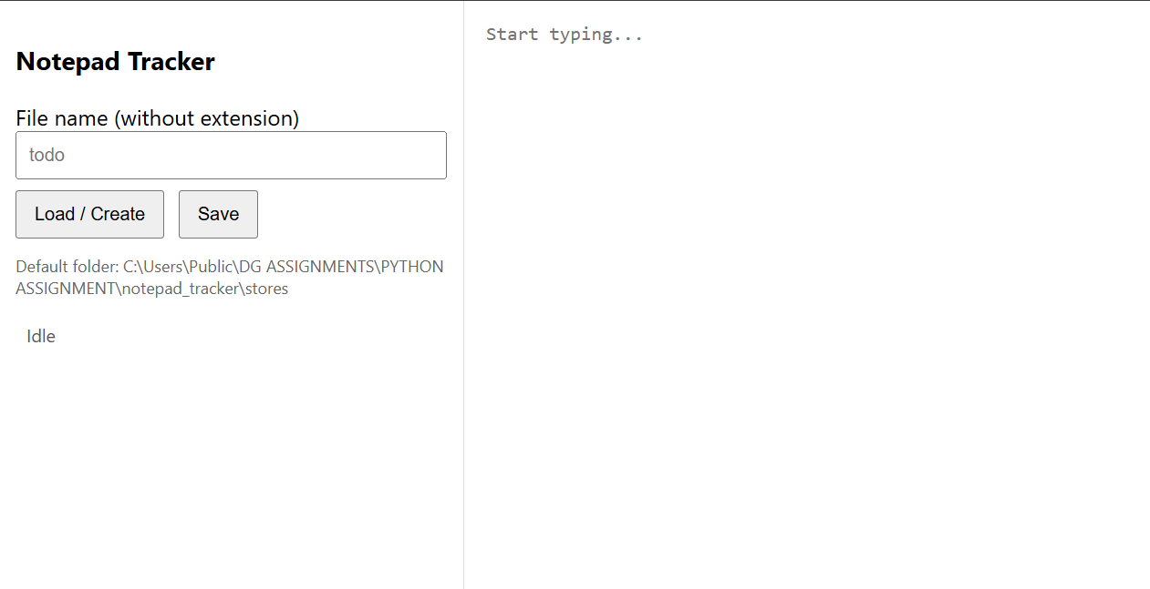

XLSX to CSV Converter

1. Question Given
“Python script that converts all the sheets of an XLSX file (Google Sheet or local file) into CSV files.
Assumption: There is a single header row in all sheets of the XLSX document.
Input:
$ python converter.py google_sheet_link/local_file_location
Output:
A folder with the same name as the input file, containing:
- Sheet1.csv
- Sheet2.csv
- …
- SheetN.csv
Example:
Input:
$ python converter.py Sample_Data - Python Assignment
Step 1: Understood the requirement**
- The script must take a **single argument** (either a Google Sheets link or local `.xlsx` file path).
- It should **read all sheets** inside the Excel file.
- Each sheet should be converted into its **own CSV file**.
- Output folder name should match the **input file name** (without extension).
- Google Sheets input link must be handled → convert the link to a downloadable XLSX.

Step 2 :--Libraries Used
I selected the following Python libraries:

**pandas** -- To read Excel and write CSV
**openpyxl**- -Required by pandas to read `.xlsx` files
**requests** -- To download Google Sheet as `.xlsx`
**os / pathlib**-- For file and folder handling
**re** --To extract sheet ID from Google Sheets URL
**tempfile**-- To store downloaded sheets temporarily

Step 3: Planned input handling
The script must detect:

Case A: Google Sheets Link
- Extract the sheet ID from the URL.
- Convert to export format:
https://docs.google.com/spreadsheets/d/<ID>/export?format=xlsx
- Download the XLSX file into a temporary file.

Case B: Local XLSX File
- Directly use the provided path.

Step 4: Planned how to read and convert sheets
- Use:
sheets = pd.read_excel(file, sheet_name=None)
This gives a dictionary:
{
"Sheet1": DataFrame,
"Sheet2": DataFrame,
...
}
- Loop through each sheet and save:
SheetName.csv
- Sanitize sheet name so that invalid filename characters are removed.

Step 5: Designed folder structure
- Extract base name from input.
- Example:
Input: Sample_Data - Python Assignment.xlsx
Output folder: "Sample_Data - Python Assignment"
- Create the folder if not existing.

Step 6: Wrote the final script (converter.py)
I wrote a complete script that:
✔ Detects Google Sheets link
✔ Downloads XLSX file
✔ Reads all sheets
✔ Converts each sheet into CSV
✔ Creates proper output folder
✔ Handles errors (invalid URL, file not found, etc.)

Step 7: Tested with Local File
Command:
python converter.py "Sample_Data - Python Assignment.xlsx"
Output folder automatically created:
Sample_Data - Python Assignment/
├── Office Supply Sales.csv
├── Food Sales.csv
└── …
All CSVs created correctly.

Step 8: Tested with Google Sheets Link
Used:
python converter.py "https://docs.google.com/spreadsheets/d/<ID>/edit#gid=0"
Workflow worked as expected:
- It downloaded the file.
- Created a temporary XLSX.
- Converted all sheets to CSV.
- Saved them in an auto-created output folder.

Step 9: Verified Assumptions
- Each sheet contained single header row (satisfies assignment condition).
- CSVs were encoded in UTF-8 with BOM (utf-8-sig) so Excel opens them properly.

Output:--

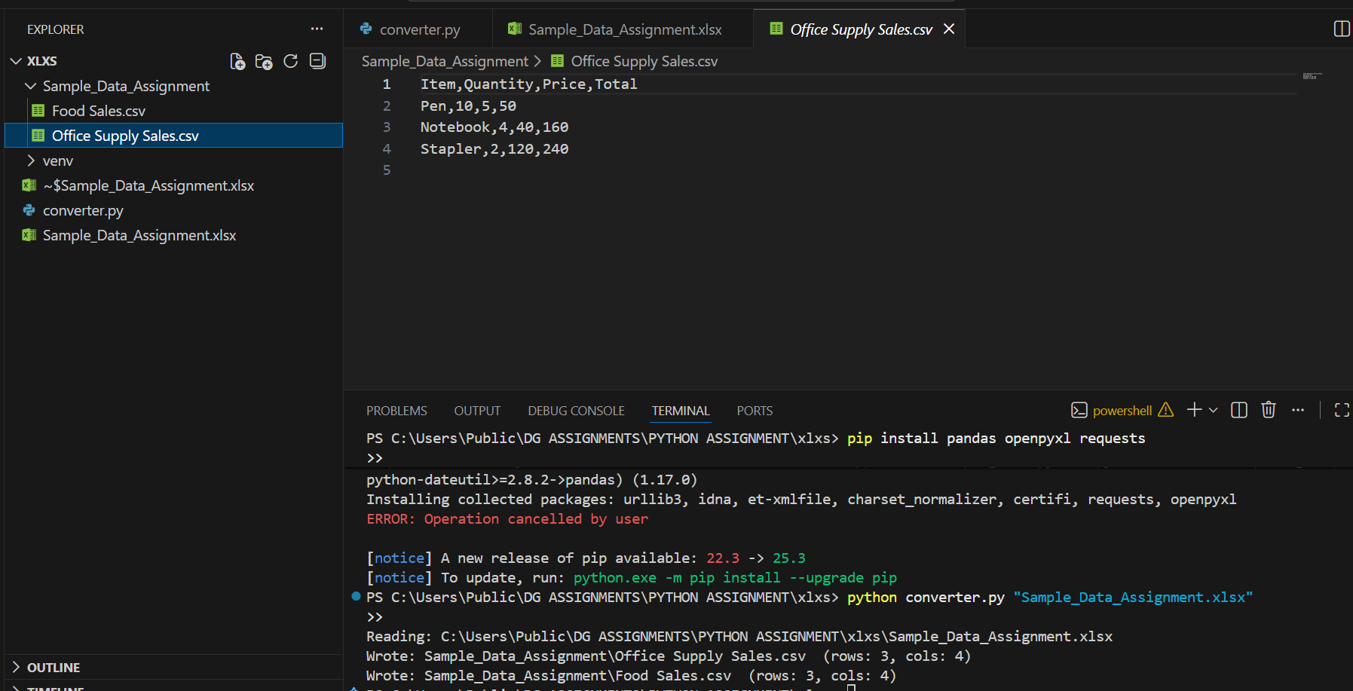

SQL INFORMATION EXTRACTION

1. Question Given
Task:
“Write a Python script that extracts information from a SQL file using regex.
Input: python extraction.py sample_stored_procedure.sql
Output: sample_stored_procedure.json.”

STEP 1 — Understanding the Requirement
First, I understood that I had to:
- Read a .sql file using Python
- Extract SQL metadata (object type, parameters, queries, tables, etc.) using regex
- Convert the extracted data into JSON format
- Save it as a .json file with the same name as the SQL file

STEP 2 — Creating the Python Script (extraction.py)
Next, I created a Python file named extraction.py.
In this script, I implemented:
- Reading the SQL file
- Removing comments
- Extracting:
  - CREATE FUNCTION / PROCEDURE header
  - Function or Procedure name
  - Parameters
  - Return type
  - SQL queries (SELECT/INSERT/UPDATE/DELETE)
  - Tables used
  - Selected columns
  - SQL body excerpt
Then I wrote the extracted information into a JSON file as:
sample_stored_procedure.json
This completed the Python part of the task.

STEP 3 — Preparing the SQL File
After the Python script, I created a complete SQL file that contained:
- A database
- A schema (sales)
- Two tables:
  - sales.customers
  - sales.orders
- Insert statements for sample data
- A SQL FUNCTION (get_customer_orders)
- A SQL PROCEDURE (update_customer_last_access)
I saved this file as:
sample_stored_procedure.sql

STEP 4 — Running the SQL File in pgAdmin
I opened pgAdmin and executed my SQL file:
- Opened pgAdmin
- Selected my database
- Opened the Query Tool
- Loaded the file: File → Open
- Selected sample_stored_procedure.sql
- Pressed F5 to execute
This successfully created:
- Tables
- Data
- Function
- Procedure
Then I verified the data using queries like:
SELECT * FROM sales.customers;
SELECT * FROM sales.orders;
SELECT * FROM sales.get_customer_orders(1, 'ACTIVE');
CALL sales.update_customer_last_access(1);
Everything worked correctly.

STEP 5 — Running the Python Script
I placed both files in the same folder:
extraction.py
sample_stored_procedure.sql
Then I opened CMD/Terminal and ran:
python extraction.py sample_stored_procedure.sql
This executed successfully and produced:
sample_stored_procedure.json

STEP 6 — Verifying the JSON Output
Finally, I opened the JSON file and confirmed that it correctly contained:
- Object type
- Object name
- Parameters
- Return type
- Tables used
- Select columns
- Extracted SQL queries
- SQL body excerpt
This confirmed that the extraction was successful.

Data Manipulation

1. Problem Statement
I was given a JSON file named sample_data_for_assignment.json containing two keys:
- cols → list of column names
- data → list of rows
My task was to:
- Load this JSON data into a MySQL table named json_to_sql_table under a new database.
- Unload the data from MySQL into a pandas DataFrame.
- Display all data in a DataFrame format.
- Convert all email addresses so that the domain ends with gmail.com.
- Clean the postalZip column so that all values are integers (removing alphabets and keeping only digits).
- Write a function to process the phone column by:
  - Removing non-numeric characters
  - Taking 2 digits at a time
  - Converting numbers 65–99 to ASCII characters
  - Replacing values below 65 with "O"
  - Ignoring last odd digit
- Store the result into a new column coded_phone_number and remove/rename the original phone column.

Step 1 – Downloading and Inspecting the JSON File
First, I downloaded the file sample_data_for_assignment.json and observed that it contained two main keys:
- "cols" (column names)
- "data" (actual rows)
I checked the structure to understand how to load it into pandas and MySQL.

Step 2 – Setting Up MySQL Database
I opened MySQL and created a database for this assignment:
CREATE DATABASE IF NOT EXISTS json_assignment_db;
I confirmed MySQL was running locally and noted the credentials I would use in the Python script.

Step 3 – Installing Required Python Libraries
I installed the required Python packages:
pip install pandas sqlalchemy pymysql mysql-connector-python
These were necessary for reading JSON, connecting to MySQL, and transforming data.

Step 4 – Creating the Python Script (json_to_mysql.py)
I wrote a Python script that:

4.1 Loaded the JSON file
- I parsed "cols" and "data"
- Converted them into a pandas DataFrame

4.2 Connected to MySQL using SQLAlchemy
- Created the database (if not already created)
- Loaded the DataFrame into a MySQL table named json_to_sql_table

4.3 Unloaded the data back into pandas
- I used pd.read_sql_table() to fetch everything from MySQL
- Displayed the first few rows to verify successful loading

Step 5 – Data Transformations
After retrieving the data from MySQL into a DataFrame, I performed all required transformations.

5.1 Email Transformation
I modified email addresses so that every email ended with @gmail.com, while keeping the username part.
Example:
john@example.com → john@gmail.com

5.2 postalZip Cleaning
The postalZip column contained:
- Strings
- Integers
- Alphanumeric characters
I cleaned it by:
- Removing all alphabets
- Keeping only digits
- Converting the result to an integer
- Replacing invalid/empty values with 0

5.3 Phone Number to ASCII Conversion
I wrote a separate function that:
- Removed characters like (, ), -, spaces
- Extracted only digits
- Took 2 digits at a time
- If number < 65 → replaced with "O"
- If 65–99 → converted to ASCII (e.g., 81 → 'Q')
- Ignored leftover last digit
Example 1:
(816) 530-4269 → 8165304269 → 81 65 30 42 69 → QAOOE
Example 2:
1-811-920-9732 → 18119209732 → 18 11 92 09 73 → OO\OI
I stored the output in a new column coded_phone_number and removed the original phone column.

Step 6 – Displaying the Final DataFrame
I printed:
- First 10 rows
- All transformed columns
- Final DataFrame structure
This confirmed that all transformations were correct.
Output:--
